The Church of the Good Shepherd, Carshalton Beeches

Installation of Acoustic Panels

Statement of Significance

Section 1. Brief history and description of the church buildings, contents, churchyard and setting
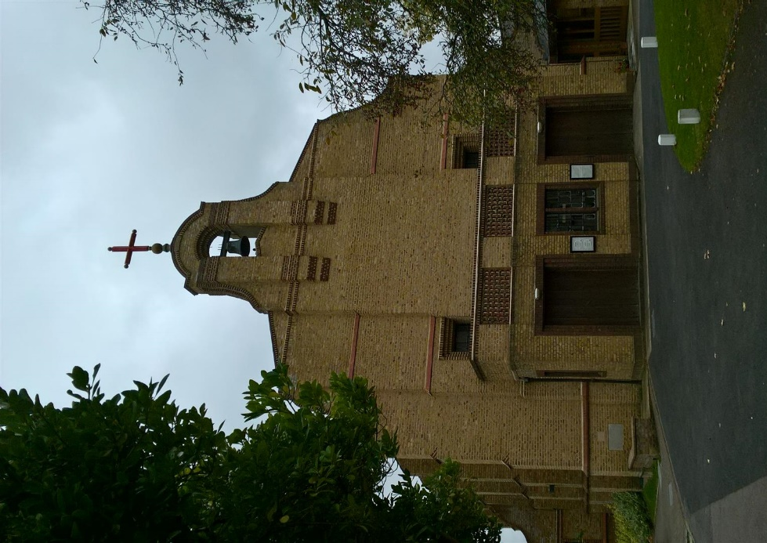
In 1928 a one-acre site in Queen Mary’s Avenue was purchased for the erection of a church and church hall and Martin Travers was engaged as architect for the project.
The new church was consecrated on 8th May 1930. The church was built with a seating capacity of 380. The interior plan is essentially a simple rectangle without any structural division between nave and sanctuary. At the west end, a gallery of steel and concrete was erected for choir and organ, and the space below was partitioned off in the 1980s to form a meeting room / narthex. Martin Travers designed many of the furnishings and fittings including the crucifix and reredos as well as the two stained glass windows, a St. Nicholas window in the north wall and a Madonna window on the south side. Externally the walls are constructed of yellow stock bricks, heavily buttressed and pierced by plain rectangular iron-framed windows. High above the west front, the gable is crowned with a picturesque belfry, which houses a single bell and contributes much to the ‘Spanish mission chapel’ appearance of the church.
It was in the millennium year that the present congregation raised £800,000 to complete the original plan to provide a chapel and also to create a new single storey extension on the south side of the church. That extension, designed by architects Carden & Godfrey, opened in 2001, and provides a new church entrance, reception area, office, kitchen, WCs, meeting rooms, an internal courtyard as well as a chapel, ‘in commendable harmony with the original structure, in both its design and the use of materials’.
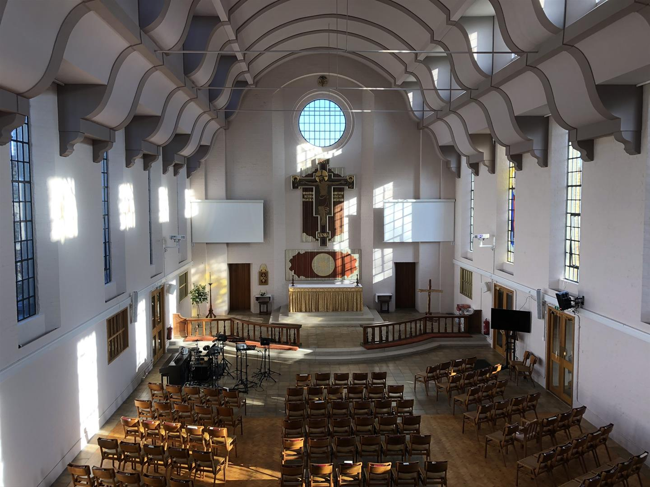
In 2010 an extension, again designed by Carden and Godfrey, was added to the north side of the church following demolition of both the old church hall (constructed in 1933) and the disused scout hut which was erected in the late 1960s. The new facilities provide a community hall, designed specifically with pre-school requirements in mind, two meeting rooms, kitchen and toilet facilities and a reception area plus extensive basement storage. At the rear of the new extension is a garden accessed from the hall and securely enclosed by fencing which offers a safe play area for pre-school usage. The old church hall had for over 40 years housed a pre-school group and this tradition now continues in the new hall.
In 2019 a substantial programme of repair and maintenance including internal redecoration and lighting was completed, overseen again by Carden and Godfrey.

Section 2. The significance of the church
The Church of The Good Shepherd, Carshalton Beeches achieved parochial status in 1965. It now serves a community of 3,350 homes and some 10,000 residents with further housing development planned. Both because of its location and architecture, it is a landmark building within Carshalton Beeches but it has also become both a spiritual centre for a church family of over 170 people and a vital resource for the local community which makes extensive use of all the facilities now provided. It is adjacent to local bus routes and in easy walking distance from the local station.
The church is located on the corner of Queen Mary’s Avenue and Gaynesford Road, in the heart of a suburban area; relatively close to local shops and a short trip down Stanley Park Road to the supermarkets etc. It is located in the heart of the community which it serves and is a well-known local landmark.
The churchyard is laid out for car parking in one corner and the rest is planted as an attractive garden. There is a small garden of remembrance for the internment of ashes, with no other significant memorials.
The present congregation have invested heavily in the building, developing a suite of meeting rooms and the chapel to the south – which are regularly used by local and regional groups for conferences and meetings etc as well as the children’s church on a Sunday and two further meeting rooms and a community hall to the north, which hosts a pre-school and uniformed organisations as well as many one-off church and community events.
The primary use for the church itself remains as a place of worship, and it is used for this purpose every Sunday and Wednesday. Services are well attended by a healthy cross section of the community. Thus, the building remains at the centre of our faith community. It is of considerable significance to our congregation, the local community and, because of its architectural merit, it is also designated as a heritage asset of national significance, which is reflected in its grade II listed status.

Section 3. Impact of the Proposals
The proposal is to attach large, fabric covered acoustic panels to the walls between the windows, above and below the trunking. The acoustic panels are frameless and are mounted on an aluminum split batten system so that no fixings will be seen. Plywood strips will fitted to the painted brickwork walls to provide an even surface to which to the split batten system can be fixed.
The plywood strips will allow fixings to be made into the brick joints, thus minimising the physical impact on the historic fabric. The assembly could easily be removed and the holes filled in the future if the acoustic panels are no longer required.
The large acoustic panels will have an impact on the character and feel of the space however the fabric colour has been selected to tonally blend with the wall colour and the lack of any visible frame will also minimize the overall impact. The acoustic panels have been set back from the window reveals and console brackets in order to allow these important architectural elements to be clearly read and understood. For these reasons, the acoustic panels will not have any impact on the significance of the interior.

Statement Of Need

Section 1. General Information
As detailed in the statement of significance the church was built in 1930, designed by Martin Travers and TFW Grant in a Spanish Baroque style. It is Grade II listed. It was extended on the south side in 2000 to provide meeting rooms and a chapel and then on the north side in 2010 to provide a community hall and further meeting rooms. A substantial programme of repair and maintenance to the fabric of the church was completed in 2019.
Diocese: SOUTHWARK Archdeaconry: CROYDON
Deanery: SUTTON
Benefice: Carshalton Beeches
Parish Legal Name: The Good Shepherd Carshalton Beeches
The church family reflects the local mix of families with children of all ages, professionals who commute to London, as well as an active contingent of retirees. Most of the congregation live in close proximity to the church.
The church includes and embraces a number of church traditions, but seeks to emphasise Bible based teaching, to encourage Spirit-filled worship and to enable all who come in to encounter God wherever they are on their journey.
The vision is ... “To know Christ, and to make Him known”, through being Rooted in Christ, Growing in Faith and Fruitful in Love.
There are 139 people on the Electoral Roll with around 80 adults and 25 children regularly attending the main Sunday service. A wide cross section of age groups including families with children of all ages attend. A smaller communion service runs on Wednesday mornings.
There are weekly youth and children’s groups during the Sunday morning service for ages 3-14. A youth group meets weekly on a Sunday afternoon, and toddler group runs on Wednesdays. In addition, there are midweek homegroups, Alpha courses, a running group and a singing group. The south extension building is used as a conference venue by various local and regional groups and organisations. The community hall is used every weekday by a Montessori pre-school group, as well as regularly by uniformed groups.
The last QI Report was undertaken in 2017 by Andy Burrell from Carden & Godfrey Architects. The inspection reported that the fabric is in reasonably good condition although in need of some repair / maintenance work which was undertaken in 2019. The inspection also noted that an upgrade to the lighting and sound systems were overdue, and these upgrades were also undertaken in 2019.

Section 2. What We Need
Within the church it is difficult for the congregation to hear and comprehend spoken word or contribute to sung worship. This is due to the construction of the building which, being a large hanger type shape with flat, painted brick walls, hard woodblock and tiled floors and plastered barrel vaulted ceilings, produces an excessive reverberation time (the time taken for sound to decrease by 60dB from its initial level once the sound source is switched off).
A report commissioned by the church and undertaken by acoustic specialists, Cole Jarman, in 2019 (attached) measured the reverberation time (T_{mf}) as 2.29 seconds. The report cites a number of sources which detail that the recommended reverberation time for educational refurbishment and larger churches with amplified speech and music should be between 0.8-1.5 seconds. The acoustic specialists recommended that the reverberation time be reduced to 1.5 seconds (being the upper limit), and that would resolve the problem.
Furthermore Cole Jarman recommended that this could be sympathetically achieved by the installation of 60m² of class C absorber acoustic panels along the side walls of the church.

Section 3. The Proposal
We propose to install eight large frameless, fabric covered acoustic panels, 1.8x3.25m between the nave windows with a further six smaller acoustic panels 1.8x1.2m of identical material directly below the large acoustic panels, all as shown on the two Carden & Godfrey drawings.
The acoustic panels have been sized to fit comfortably below the ceiling console brackets and set back from the window reveals in order to allow these important architectural elements to dominate.
The acoustic panels will be fixed using an Aluminum split batten system by Gooding Aluminum which is designed to interlock and grip, avoiding the risk of the panels “popping off”. See sketch below.
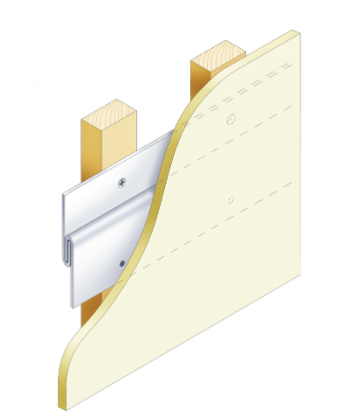

The split battens will be fixed to plywood strips rather than timber battens (as shown in the sketch) to minimize the projection from the wall and allow for local packing out to overcome undulations in the walls.
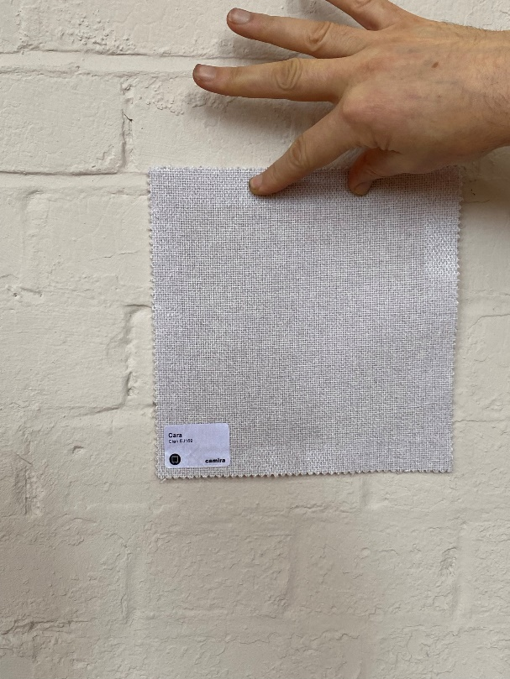
The acoustic panels are frameless, 25mm thick, fabric covered and the fabric colour recommended by our Inspecting Architect is Cara – Clan EJ169. This photograph (right) shows a sample of the fabric against the existing wall colour.
This will achieve very close to the 60m² of acoustic panel area recommended by Cole Jarman. However because this is still at the high end of the recommended reverberation time, we have provisionally indicated the location of six further acoustic panels directly below the windows and matching the width of the window reveals (1.53x1.2m) which will be installed only if they are needed.
The acoustic panels will be supplied and installed by “Resonics” – a professional firm of acoustic treatment specialists. Their quotation is attached.
Other potential acoustic treatments (e.g. the installation of carpet, use of soft furnishings, banners etc.) have been suggested but the acoustics specialists have advised that they will not provide the necessary decrease in reverberation time. Carpet in particular would also have a more significant impact on the overall character and appearance of the interior.
Having regard to earlier advice of the DAC, we have worked closely with our Inspecting Architect and fully accepted his advice regarding the design and layout of acoustic panels, the colour and type of acoustic panel, and the fixing method so that the aesthetic impact on the character and appearance of the church is minimised.

Section 4. Why Do We Need It Now?
The improvement in acoustics in the church has always been needed, but due to cost constraints was not addressed in the 2019 refurbishment.
For a separate reason (the failure of the church heating system) regular worship was moved to the church hall six months ago and many comments have been received from members of the congregation that finally they can hear the sermon and participate fully in the services.
On moving worship back to the church it is clear that we need to take action to make it easier for all to hear. It is not only those who suffer some hearing loss who struggle. Even those with normal hearing sometimes find it difficult to hear those leading the services and our worship group.
The problem seriously affects both the preaching of the word (mission) and worship of the church. If it is not addressed, there is a real danger that people will simply leave because they cannot participate. Furthermore, the current situation unfairly disadvantages those with poor hearing, which is both inequitable and unjust.

Section 5 Conclusion
The current acoustics within the church are unsatisfactory and harmful to the faith life of our church family. The problem can be solved by installing acoustic panels on the interior side walls of the church.
Whilst installing acoustic panels will have some visual impact on the interior, we have entirelyaccepted the advice of our Inspecting Architect to ensure that any impact is minimised, that the design blends well with existing features and colour scheme and is completely reversible.
It is essential that we improve the quality of sound in the church for the benefit of all those attending and to ensure that we can continue with our core purposes of worship and mission.

LIST OF ANNEXES

Annex A - Cole Jarman Internal Acoustics Report, 12 December 2019

Annex B – Carden & Godfrey Drawings Showing Layout of Acoustic Panels, Sections JJ and HH, 7 April 2022

Annex C – Acoustic Panels Cara Colour Sheet

Annex D – Resonics Quote, 17 March 2022

